Case 4-Eur-Italy-Roman-Dancing girl-bronze-200 CE

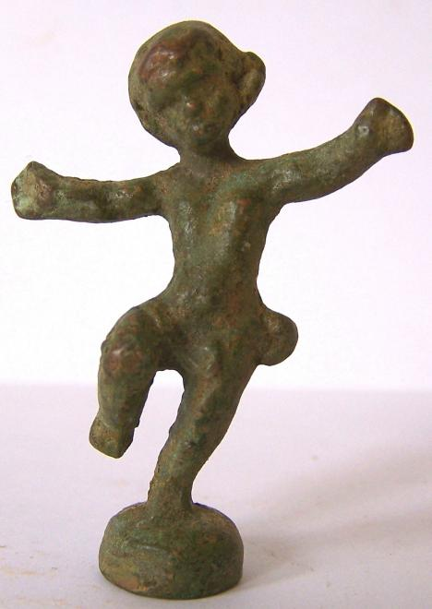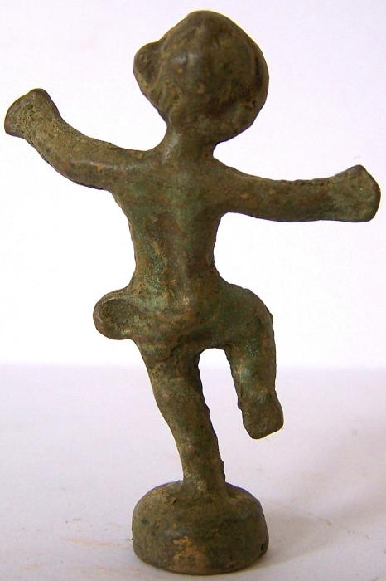
Case no.: 4
Accession Number:
Formal Label: Italy-Roman-Bronze bust-Female
Display Description:
Such bronze figurines were popular as likenesses of family members and in addition as votive objects which soldiers would take on expeditions to remind them of their loved ones at home.
LC Classification: C135
Date or Time Horizon: ca 200 CE
Geographical Area: Rome
Map:
GPS coordinates:
Cultural Affiliation: Roman Empire
Medium: bronze
Dimensions: 5,5 cm x 3 cm

Weight:
Condition:
Provenance: Old English collection
Discussion:
References:

